NAME: P.Pallavi REG NO: 192525448 SLOT - D
COURSE: CSA1407 COMPILER DESIGN CASE STUDY

SET 1
Q1. Parse Tree / Syntax Tree Representation

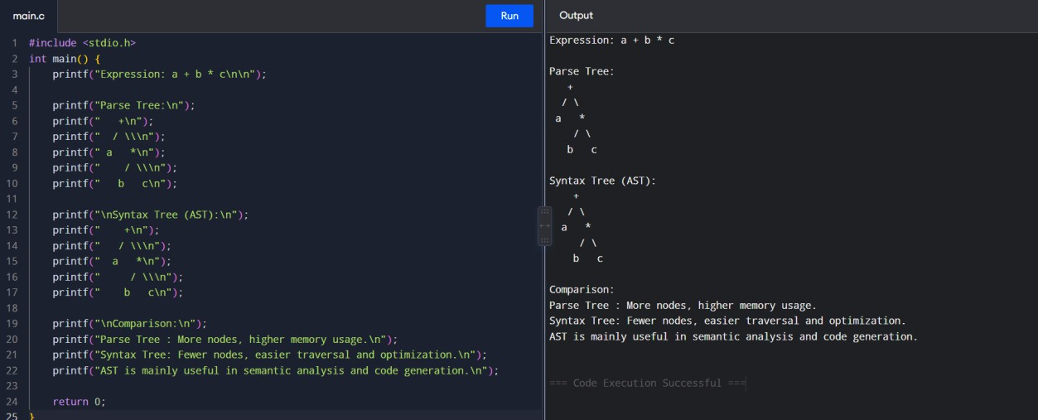

Q2. Bottom-Up Evaluation
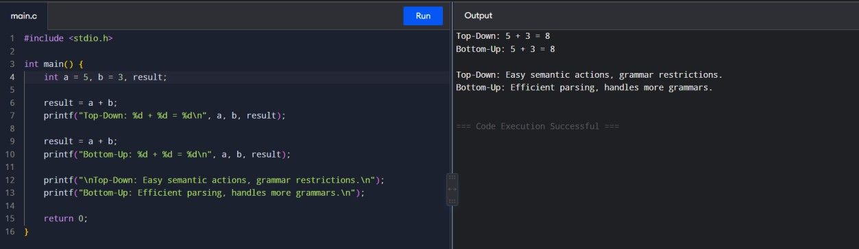

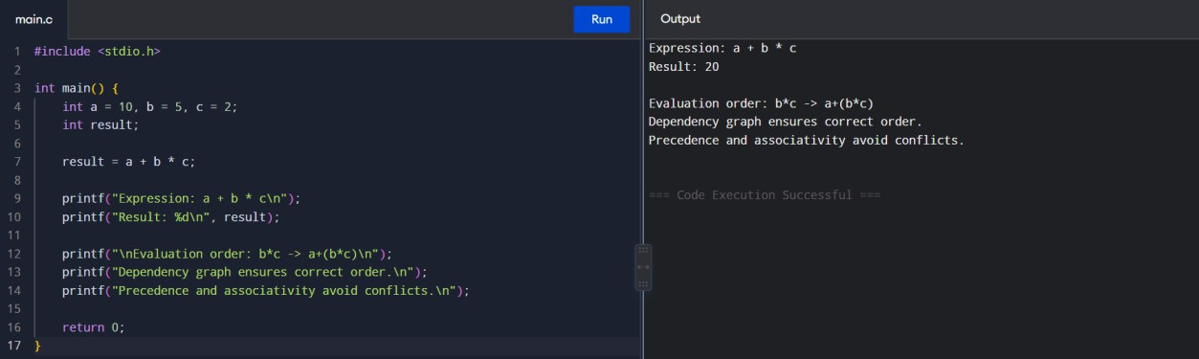

Q4. Static Type Checking
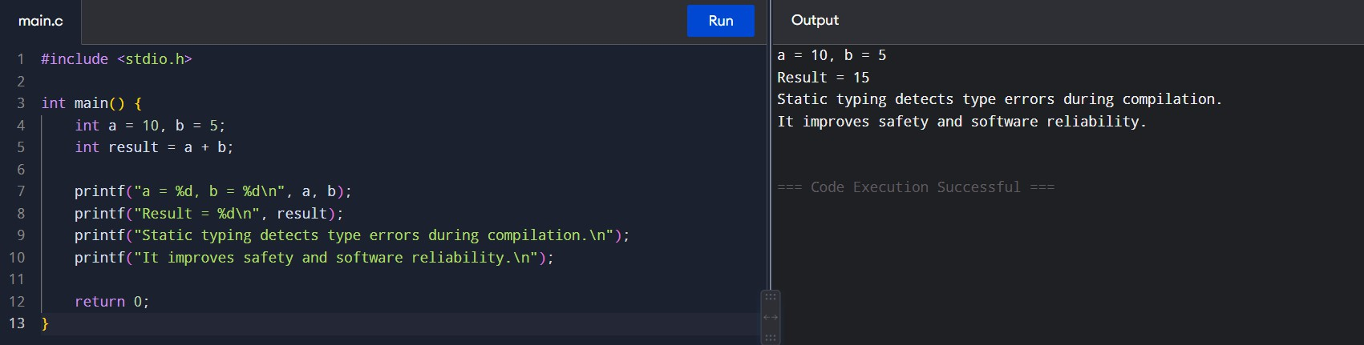

Q5. Function Overloading / Type Resolution Demonstration
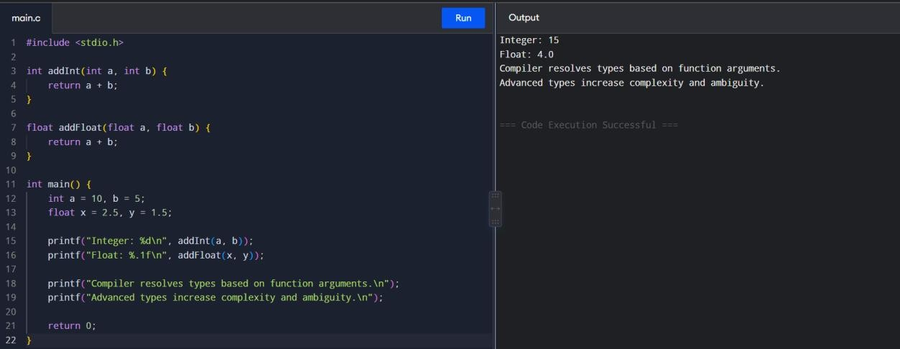

Q1. Synthesized Attribute
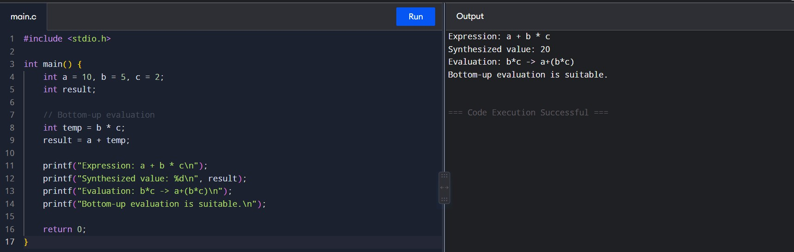

Q2. Type Conversion
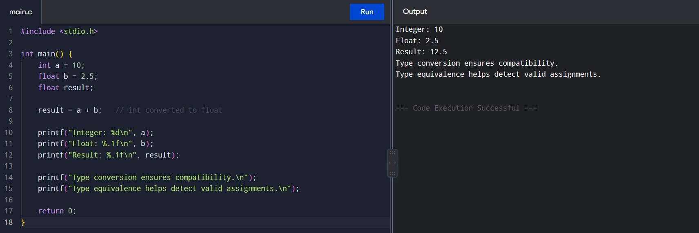

Q3. Syntax Tree and Bottom-Up Evaluation
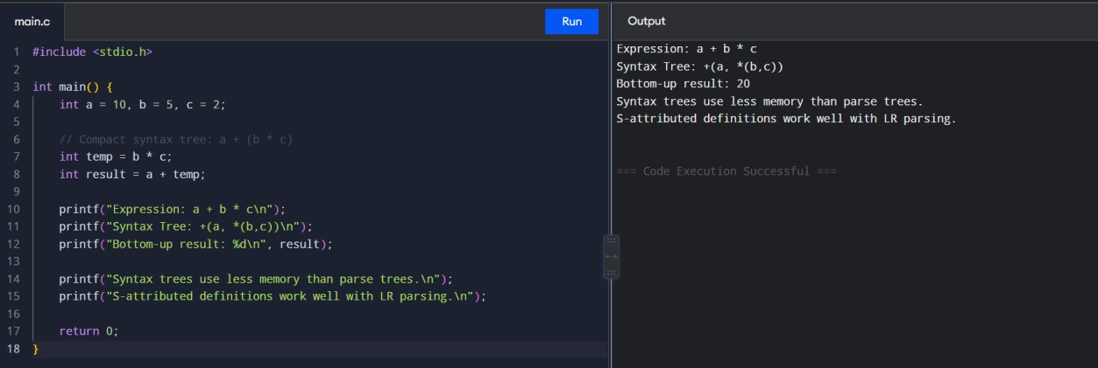

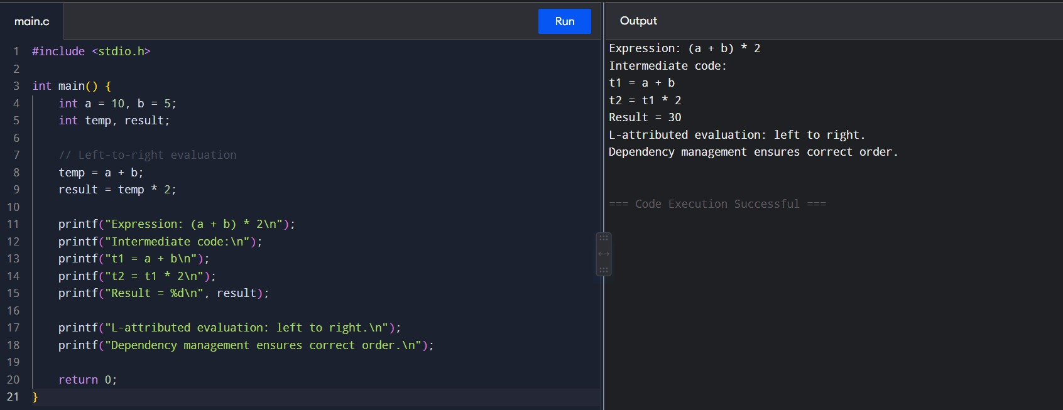

Q5. Type Checking
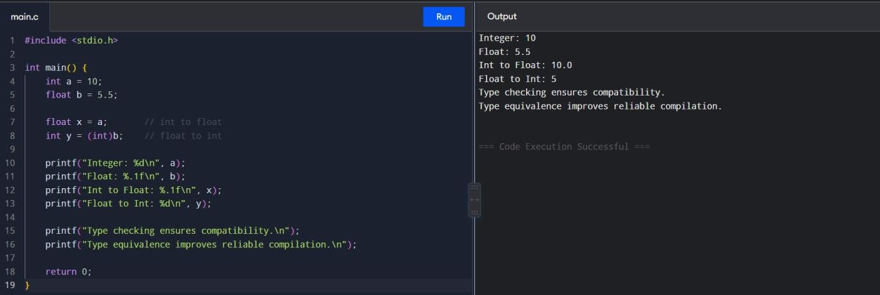

SET 3
Q1. Syntax-Directed Definition – Expression Evaluation
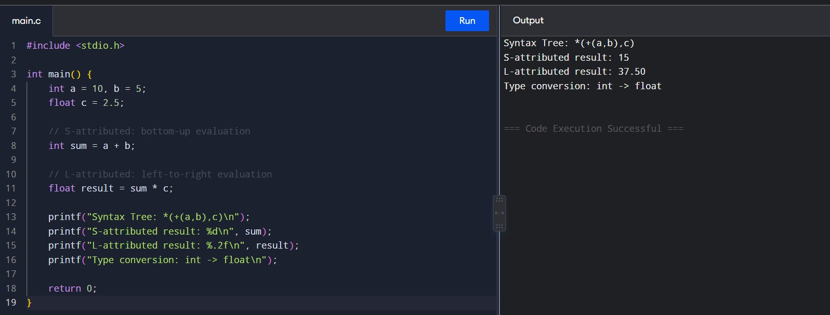

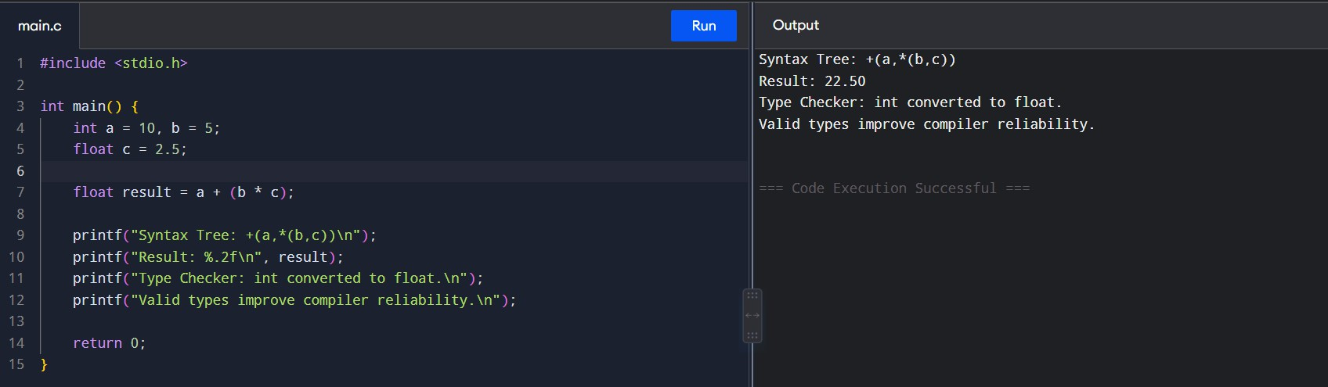

Q3. Bottom-Up Expression Evaluation
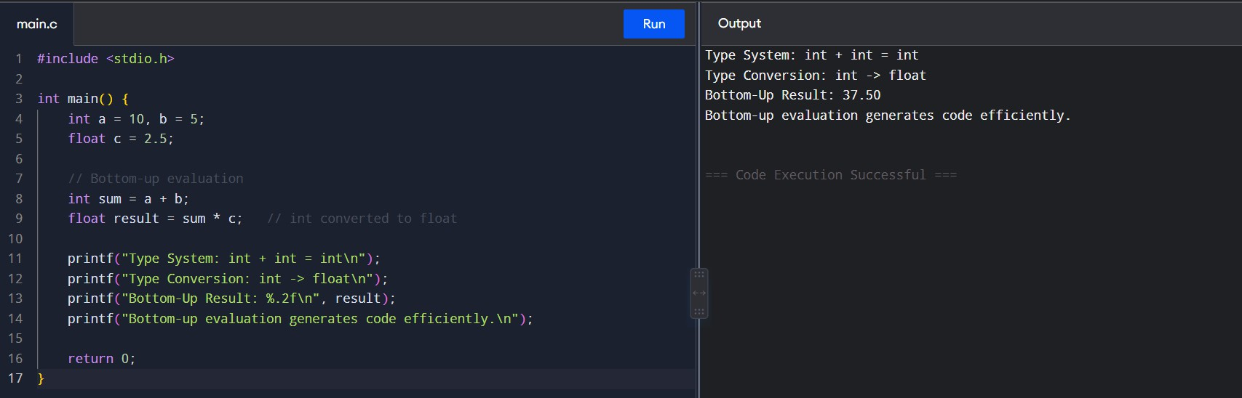

Q4. Type Equivalence Checking
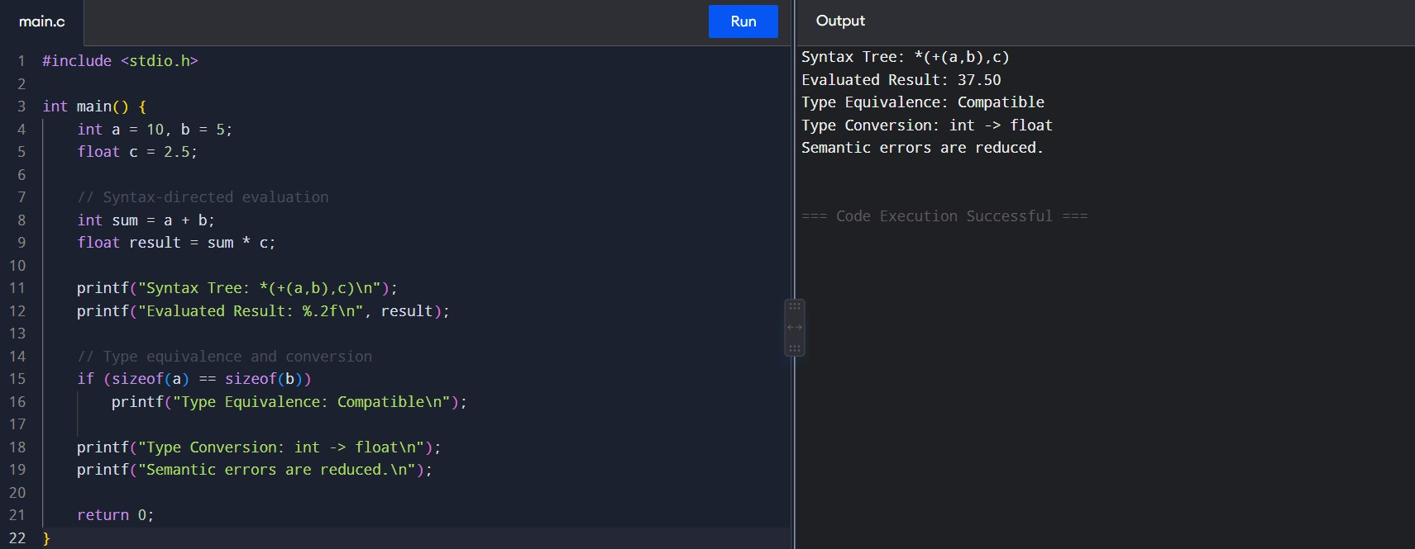

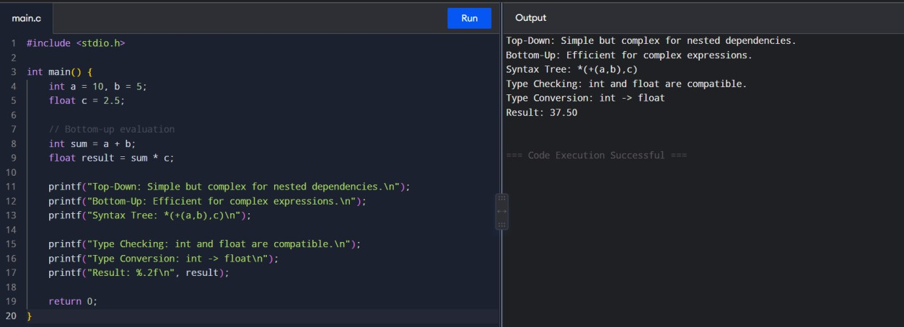

SET 4
Q1. Syntax-Directed Definition and Type Conversion
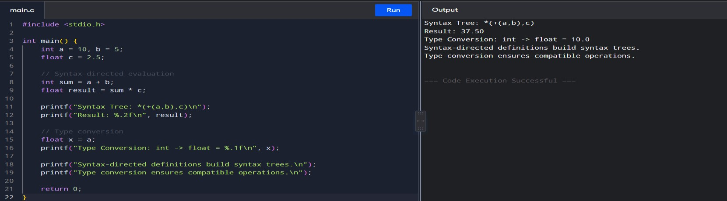

Q2. Top-Down and Bottom-Up Evaluation
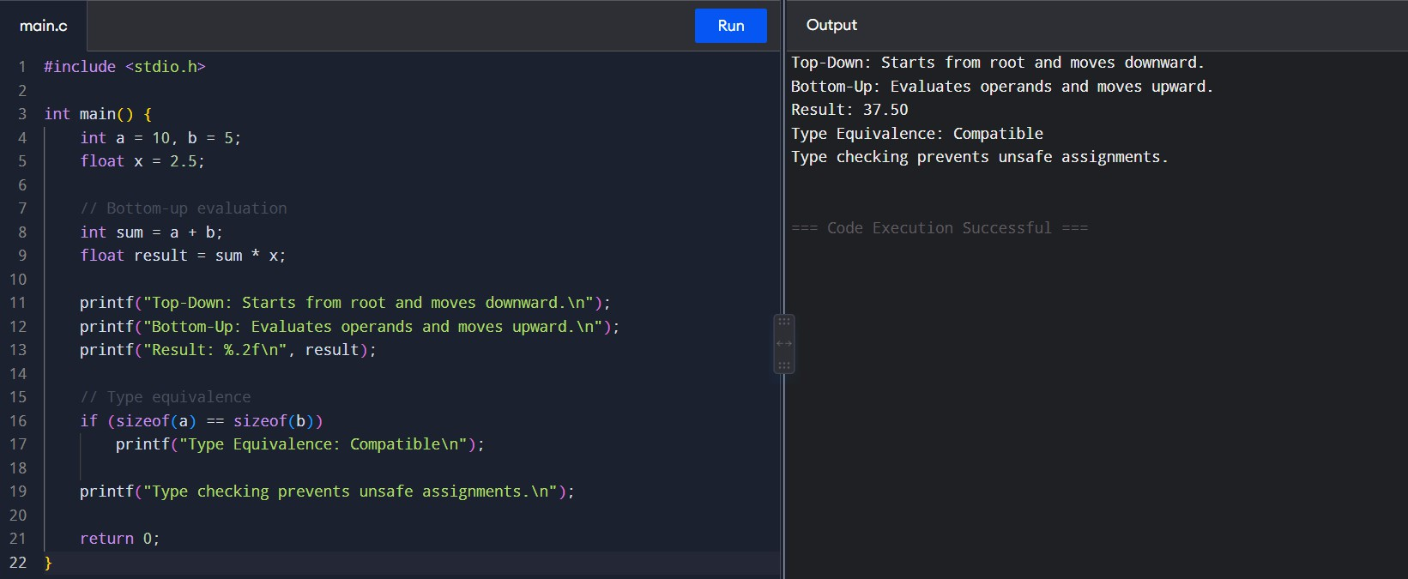

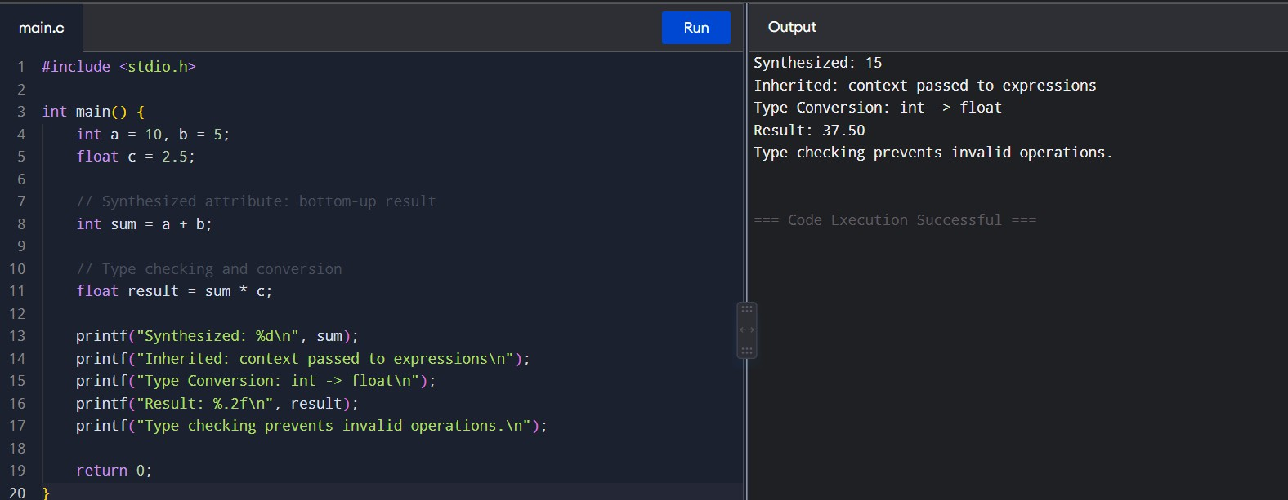

Q4. Type Equivalence and Type Conversion
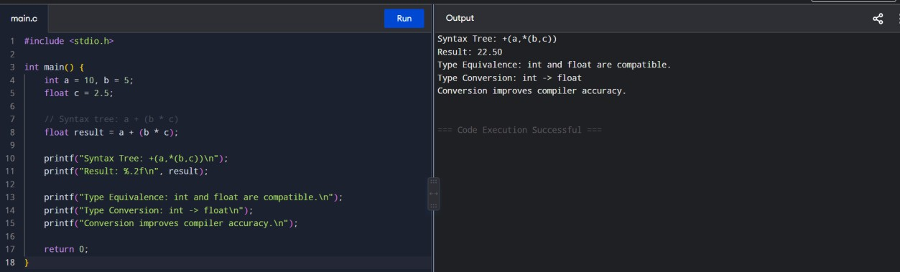

Q5. S-Attributed and L-Attributed Definitions
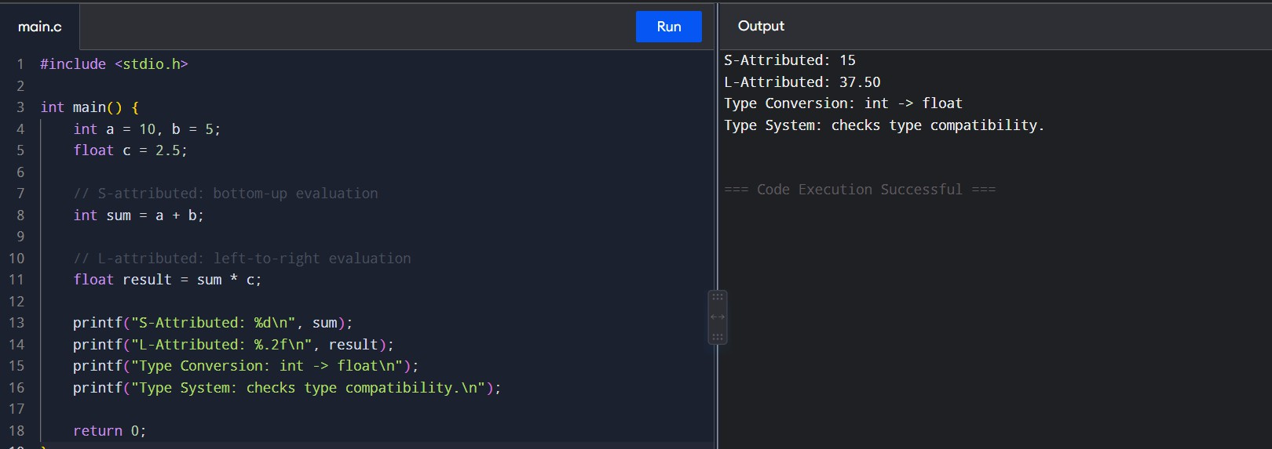

Q1. L-Attributed Definition

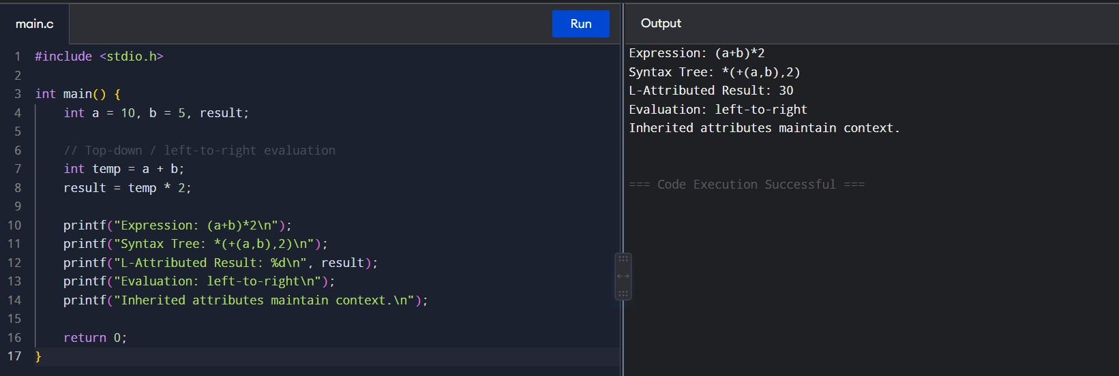

Q2. Bottom-Up Evaluation
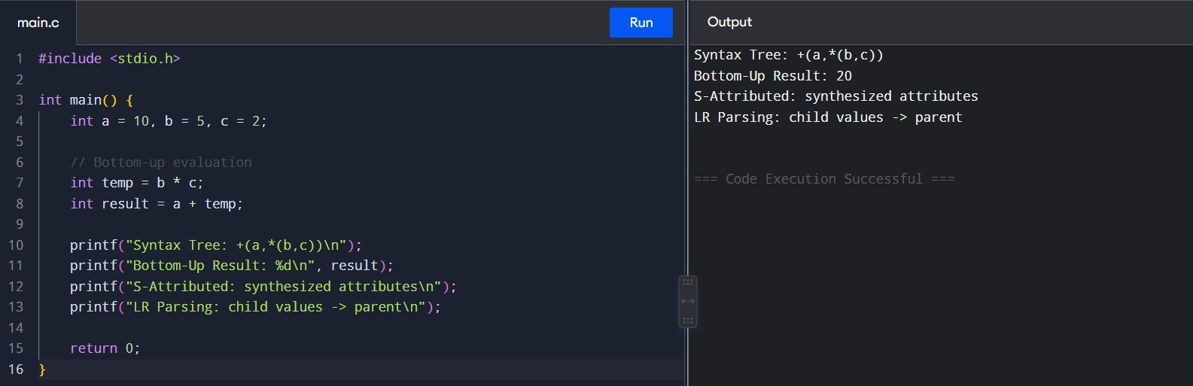

Q3. Type Equivalence
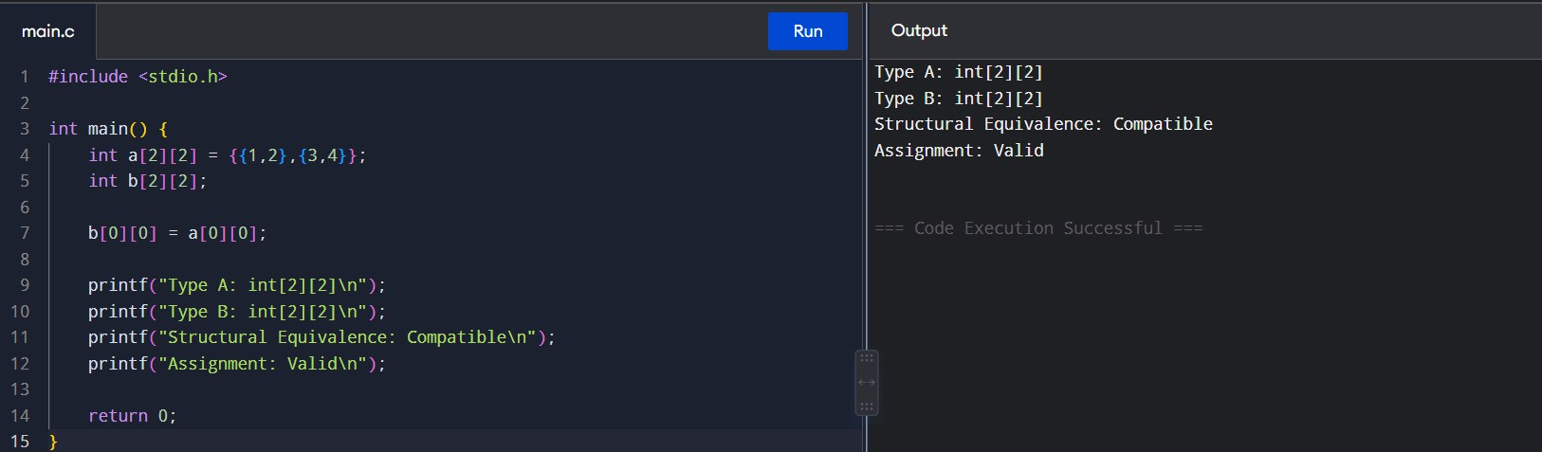

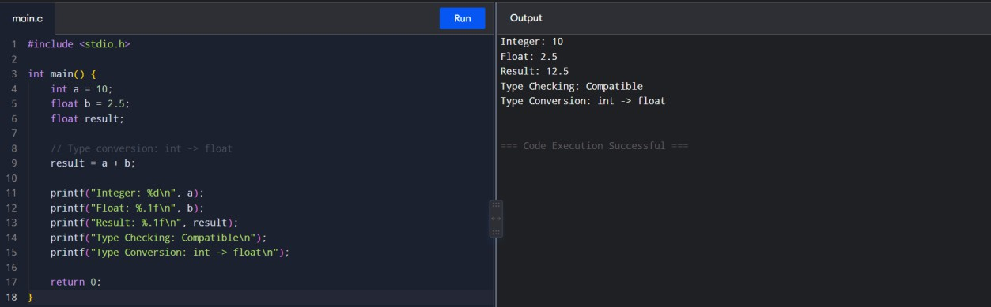

Q5. Attribute Dependency and Expression Evaluation
